**DAILY ONLINE ACTIVITIES SUMMARY**

|  |  |  |  |
| --- | --- | --- | --- |
| **Date:** | 12/06/2020 | **Name:** | Krishnitha |
| **Sem & Sec** | 4th sem, A Section | **USN:** | 4AL18CS039 |
| **Online Test Summary** | | | |
| **Subject** | Adalitha Kannada | | |
| **Max. Marks** | 25 | **Score** | 24 |
| **Certification Course Summary** | | | |
| **Course** | Introduction to Information Security | | |
| **Certificate Provider** | Great Learning Academy | **Duration:** | 4 hrs |
| **Coding Challenges** | | | |
| **Problem Statement:**  1) Given two positive integers start and end. The task is to write a Python program to print all Prime numbers in an Interval.  2) Given an array of N elements and an integer M. Now, the array is modified by replacing some of the array elements with -1. The task is to print the original array.  The elements in the original array are related as, for every index i, a[i] = (a[i-1]+1)% M. It is guaranteed that there is one non zero value in the array. | | | |
| **Status:** Executed | | | |
| **Uploaded the report in GitHub** | | YES | |
| **If yes Repository name** | | <https://github.com/krishnitha/Python-coding>  <https://github.com/krishnitha/C-coding> | |
| **Uploaded the report in slack** | | YES | |

**Online Test Details:**

Today we had assessment in the subject Adalitha Kannada. The test comprised of all 10 chapters. There were 25 questions of one mark each, out of which I scored 24.

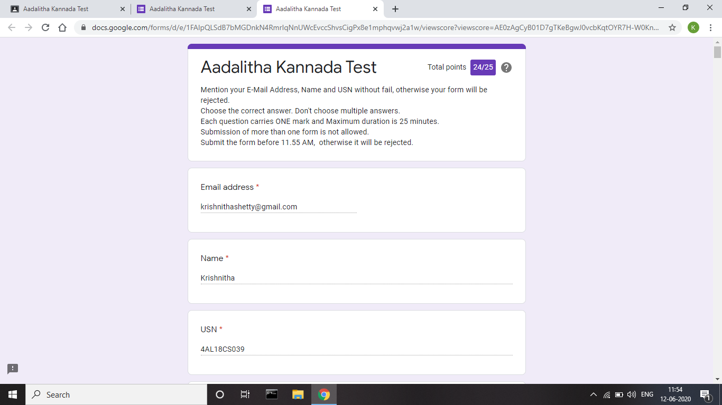

**Certification Course Details:**

Today I have completed the course Introduction to Information Technology. I have learnt about SQL injection, Client-server platform and about various listing techniques like white listing and bad listing. Also learnt about password security and its different means.

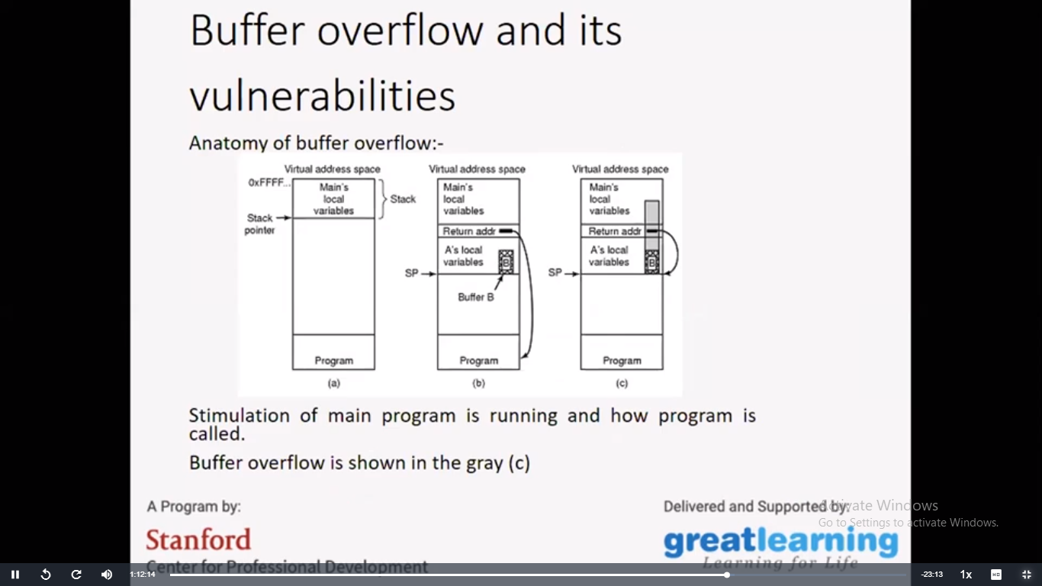

**Coding Challenges Details:**

**Problem 1:** Given two positive integers start and end. The task is to write a Python program to print all Prime numbers in an Interval.

**Explanation:** A prime number is a natural number greater than 1 that has no positive divisors other than 1 and itself. The first few prime numbers are {2, 3, 5, 7, 11, ….}. The idea to solve this problem is to iterate the val from start to end using a for loop and for every number, if it is greater than 1, check if it divides n. If we find any other number which divides, print that value.

**Solution:** Uploaded it in GitHub

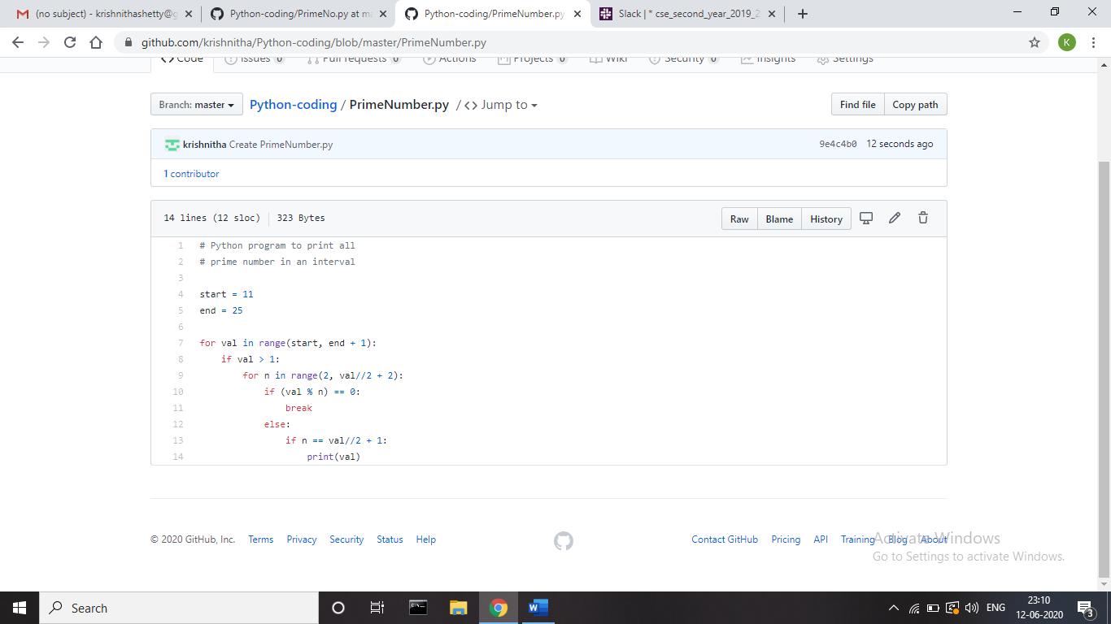

**Problem 2:** Given an array of N elements and an integer M. Now, the array is modified by replacing some of the array elements with -1. The task is to print the original array. The elements in the orginal array are related as, for every index i, a[i] = (a[i-1]+1)% M. It is guaranteed that there is one non zero value in the array.

**Examples:**  
Input: arr[] = {5, -1, -1, 1, 2, 3}, M = 7  
Output: 5 6 0 1 2 3  
M = 7, so value at index 2 should be (5+1) % 7 = 6  
value at index 3 should be (6+1) % 7 = 0

Input: arr[] = {5, -1, 7, -1, 9, 0}, M = 10  
Output: 5 6 7 8 9 0  
Recommended: Please try your approach on {IDE} first, before moving on to the solution.  
Approach: First find the index of the non-negative value index i. Then simply go in two directions i.e. From i-1 to 0 and i+1 to n.

For index i-1 the value can be calculated by (a[i+1]-1+m)%m because (a – b) mod p = ((a mod p – b mod p) + p) mod p.  
For indexes i+1 the values can be calculated by (a[i-1]+1)%m.

**Solution:** Uploaded it in GitHub

